Carbon Tax Misfire

“We can have democracy in this country, or we can have great wealth concentrated in the hands of a few, but we can't have both.” Louis D. Brandeis

“It is dangerous to trust our future to market forces because these forces do what’s good for the market rather than what’s good for humankind or the world.” Yuval Noah Harari, “Homo Deus, A Brief History of Tomorrow”

“Wealth is power.” Adam Smith

“Even if expense were no object, none of these [biosphere] services could be performed at such scales and with such efficacy by any anthropogenic means. Our dependence on biosphere services is literally a matter of survival, and that’s why the integrity of the biosphere matters.” Vaclav Smil

Tony Noerpel

Proposed legislation called the Energy Innovation and Carbon Dividend Act, H.R. 763 would introduce a carbon tax and dividend [wiki 763]. Supporters tout it as “The Bipartisan Climate Solution” to climate change but it is not bipartisan. Of 81 sponsors 80 are Democrats. The lone Republican, Francis Rooney announced in October 2019 that he will not run for reelection to congress in 2020 [wiki rooney]. They claim it is a form of progressive taxation and it is not. It does nothing to alleviate extreme wealth and power inequality. They claim putting a price on carbon will save us from climate change without any evidence and while ignoring better solutions. They are pretending a revenue neutral tax will encourage markets to solve our problems for us automatically. They will not. Further, perhaps most egregiously, it compromises the Clean Air Act, which is one of the most effective pieces of bipartisan legislation ever enacted. H.R. 763 currently makes exceptions for agriculture, which contributes 10% of emissions and military so the door is already open for further compromise by special interests.

Carbon taxes were first proposed by David Gordon in 1972 [wiki carbon]. Other “market-friendly” solutions such as emissions trading were first investigated between 1967 and 1970 and proposed to congress in 1972 [wiki emissions]. After 50 years, we should not think that such proposals are any more politically feasible than proposals that would actually work to reduce emissions and benefit society. Since about 1980 conservatives have taken an oath never to pass more taxes [grover] so compromise would appear to be unavailable.

Between 1935 and 1981 the margin income tax rate, applying to all sources of income, was between 70% and 80% and as high as 94%. The purpose was not just to raise revenue but to ensure fairness and limit wealth and power inequality [Saez]. The US economy flourished during this time, confirming that even if high margin tax rates were not responsible for the success of the economy, they did no harm. Including all taxes, the 400 richest Americans paid about 50% of their income in taxes and the bottom 50% of Americans paid about 25% of their income in taxes. This is how progressive taxation is defined. Sales taxes are not progressive [Saez]. Today the richest 400 Americans pay only 23% of their income in taxes while the poorest Americans pay on average about 25%. That is regressive taxation. Insufficiently taxing the extremely wealthy allows fortunes to grow at the expense of the poor and threatens our democracy. Current distribution of wealth and power in the United States is shown in Figure 1. As is evident, we live in an oligarchy and only marginally a democracy. Adam Smith was right. Capitalism is breeding extreme wealth and power inequality such that CEOs and billionaires have become America’s politburo centrally planning our economy to their benefit. This oligarchy is funding the lie that climate change is a hoax.

H.R. 763 impact was studied by Kevin Ummel for the Citizens Climate Lobby, the proponent of the proposed legislation [Ummel]. This appears to be the justification for imagining this scheme is progressive. Ummell did not account for administrative overhead and did not account for exclusions such as for agriculture and the military but it was written in April 2016 and Ummel could not have anticipated how it would evolve. Still it is excellent research and we can use its results qualitatively if not quantitatively. Figure 2 is from his paper and from this we can clearly see who gets hurt and who benefits. The lowest deciles include populations of undocumented workers and the homeless. PEW research estimates there are 11.3 million people living in the US without authorization and 8 million of them are working [Dudley]. There are an estimated 550,000 homeless [mfol]. These people will not receive a dividend but will bear huge costs relative to their incomes. The richest Americans, who have the largest emissions, will not be impacted at all relative to their incomes and wealth. They can write off most of the expenses. As Emmanuel Saez and Gabriel Zucman point out all consumption taxes are regressive because the working poor are forced to spend all their income while the wealthy spend very little of theirs. The middle class within the 60 to 95%-tile will be hard hit also. These are people who vote and who will be aware they are being screwed. Importantly, it is not a progressive tax. Candidates Sanders, Warren and Biden all have proposed progressive taxes for America [ES] which should be considered at a much higher priority than H.R. 763. Resolving inequality will benefit the climate much more than a carbon tax.

To put faces and names on the negative consequences of H.R. 763, on Sunday, June 7, 2020, the Washington Post published an article by Greg Jaffe describing a newly homeless family in Florida Sergine Lucien, Dave Marecheau and their two children. Buried in the story was this: “In theory, they qualified for a $3,400 federal stimulus check, but they had no bank account or address to collect it.” After the COVID19 recession, the ranks of the homeless will swell as the bank accounts of the extremely wealthy expand, thanks to FED policy, including many officials in Trump’s administration [Elliott] exactly as happened after the credit crisis of 2007 [Glantz]. Marecheau was working two jobs and was laid off from both and is entitled to unemployment insurance, which he is also not able to collect because the Florida unemployment office is overwhelmed and understaffed. Health care in the US is also a form of regressive taxation adding to the burden of the poor and their children.

Progressives understand the danger to our democracy of extreme wealth and power inequality as evident in Figure 1 and as described for us by Justice Louis Brandeis. Note that 38% of Americans have no aggregate wealth and that a vanishingly small number of Americans have 30% of all wealth and power equivalent to the wealth and power of the bottom 94% of Americans. The success of the oligarchy to dictate policy is well documented by Gilens and Page [Gilens] and is evident by the extent to which taxes paid by corporations and the wealthy have been eroding since 1980 [Saez].

If we continue to ignore extreme wealth and power inequality, capitalism and markets will continue to exacerbate the problem. The numbers of Americans with no wealth at all, the numbers with no health care and with no jobs will grow. Unregulated capitalism eats poor people, devours nature and destroys the future for our children. We are watching that happen. Wealth is going to rentiers based on greed and not entrepreneurs based on merit [Glantz].

Figure 3 shows the relationship between energy and GDP. They are tightly coupled and energy is causal as a consequence of physical and ecological law [Hall]. Economists lacking sufficient science background have conveniently placed the invention of capitalism at the knee of the curve but this is false. Capitalism is as old as civilization and slavery. Markets have for millennia been able to determine the price of a slave but cannot determine the value of a human [Meltzer]. Markets can determine the price of a bottle of water but cannot determine the value of an albatross or a whale which dies eating our plastic waste. Economic price theory has nothing to do with value.

One problem with H.R. 763 is that the middle class and the working class do not have any alternative options. There is no mass transportation. They cannot afford EVs and hybrids. The do not own their homes but rent and so have little control over their energy consumption. The proportion of home owners fell after the Great Recession of 2007 and is falling again as a consequence of the COVID19 recession. Both of which were great buying opportunities for elites [Glantz]. A revenue neutral tax does not raise funds necessary to creating low-carbon alternatives or for the eventual evacuation of coastal communities, such as Norfolk, Virginia.

There is no evidence that a stick would work better than carrots to reduce emissions. Carrots cost money to build out infrastructure such as mass transportation and finance building restoration especially for the working and middle classes but people need low emission alternatives. And where a stick is required, regulation makes for a more effective stick than taxes.

Here are three progressive sources of government revenue for accomplishing these initiatives.

* $450 billion /year national savings mostly benefitting the working class, with Medicare for all (plus 70,000 lives) [Galvani]
* $650 billion/ year with cuts in defense spending to put us on par with other nations.
* $750 billion /year raised by implementing progressive wealth taxes. [Saez]

I think most people would support a return to the progressive tax policies of the Eisenhower administration because most people have a sense of fairness. When Trump and Zuckerberg don’t pay taxes, the rest of us don’t want to either and for good reason. But if the wealthy are forced to pay their fair share, others don’t mind. Also, if Apple and other corporations paid taxes, the burden on the middle and working classes could be reduced.

Cutting defense spending would cut military emissions in proportion without the need for a tax. The US military has emitted more than 1.2 billion metric tons of greenhouse gases since 2001 [Darby].

10% of GHG emissions in our country are from agriculture [EPA]. With the appropriate incentives, we can replace intensive chemical farming with organic farming which is more resilient and which will regrow our soils rather than destroy them. Earthworm biomass may be 88% lower in land under intensive agriculture as compared to organic farming [Blakemore]. Good agricultural practices can store carbon and reduce chemical runoff into our estuaries [NAS]. There are success stories such as Maryland’s Department of Agriculture subsidies to farmers to grow winter cover crops. But we need revenue.

Audrey Berry studies a carbon tax and redistribution scheme applied to France [Berry], but it is a different country. France has a national health care plan, well-developed rail system with high speed links, opposition to chemical agriculture, low cost college, and other benefits and social services unavailable in our country. The source of their electricity in mostly nuclear. Still, the yellow-jackets rioted.

Finally, H.R. 763 has two provisions which would weaken the Clean Air Act by limiting the Environmental Protection Agency from placing restrictions on greenhouse gas emissions under some conditions. For this reason, it is opposed by the Center for Biological Diversity. Conservatives have been trying to weaken the Clean Air act since President Reagan’s tenure despite the fact that during the Nixon Administration the Clean Air Act passed with unanimous bipartisan support. It is ironic that well-intentioned Democrats are the ones who may successfully weaken one of the most successful bipartisan environmental policies in history.

The most serious problem confronting humanity is the ongoing sixth extinction [IPBES] not climate change which is only a contributor, though growing alarmingly. Habitat destruction, over exploitation and pollution are more significant contributors at the moment according to the World Wildlife Fund [WWF].

The real harm of H.R.763 is not its regressive policy, but that it distracts us from implementing a truly progressive program of reform including better regulation of greenhouse gases, real progressive tax policy, Medicare-For-All, reforming and demilitarizing our police departments, reducing college costs, forgiving college debt, improving social safety nets for our disadvantaged, building out sustainable infrastructure, increasing protection of the environment and biodiversity, subsidizing resilient and sustainable agriculture and so much more.

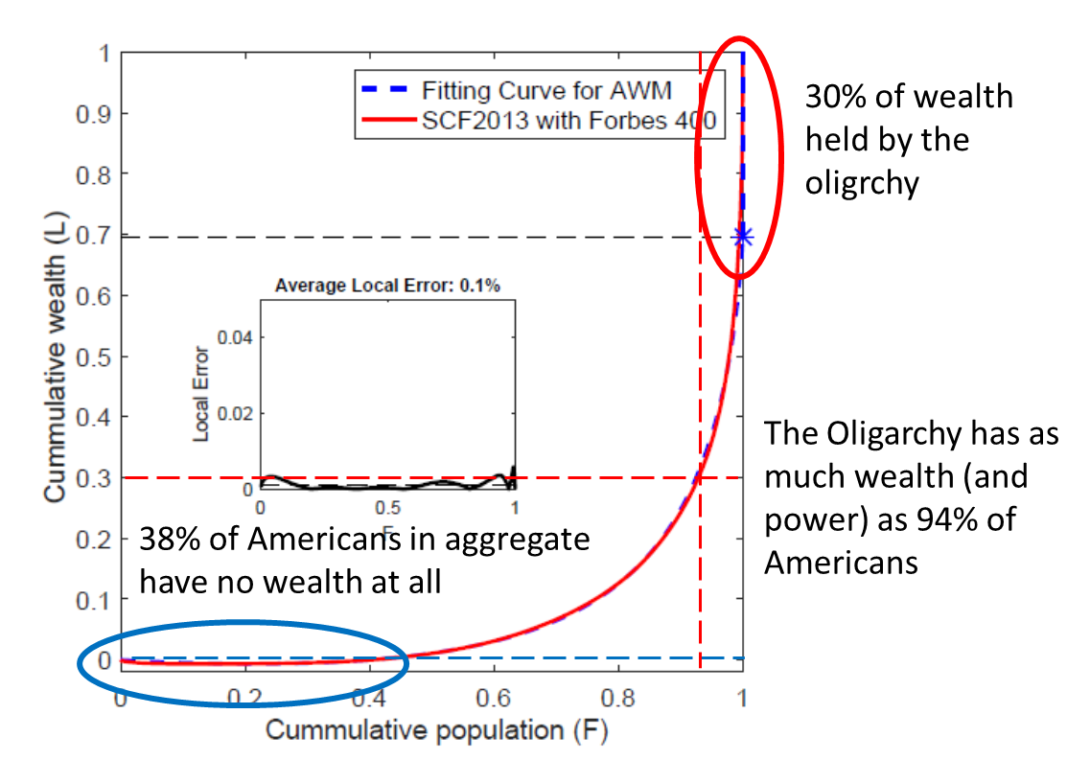

Figure 1. Wealth distribution in America adapted from [Li]. I’ve added the red oval and the black dashed line to indicate the wealth controlled by the oligarchy and the blue oval to indicate the 38% of the population which in aggregate has no wealth (the dashed blue line) and the red dashed lines to indicate the total population which owns as much wealth as the oligarchy.



Figure 2. Additional costs of goods and services and the dividend amounts per decile. Source: [Ummel]

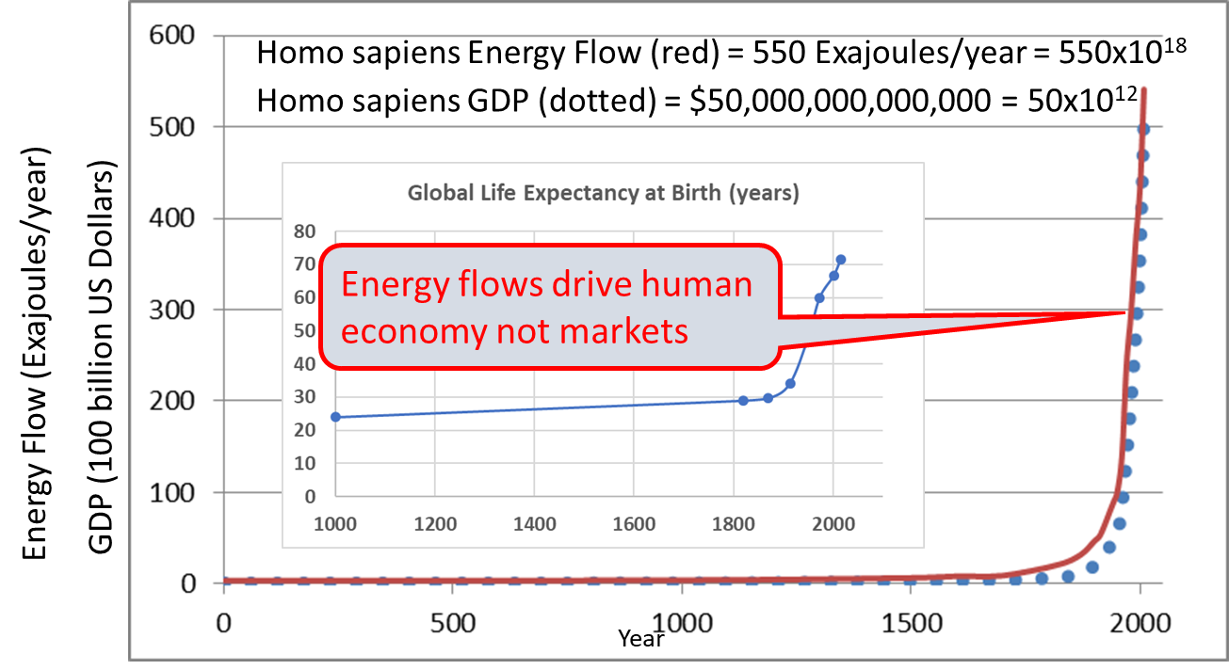

Figure 3. Exosomatic energy flow drives economic growth and human progress. “The human system grows through a self-perpetuating feedback loop in which the consumption rate of primary energy resources stays tied to the historical accumulation of global economic production through a time-independent factor of 9.7 ± 0.3 mW per inflation-adjusted 1990 US dollars” [Garrett]. Data sources: [Garrett], [Maddison], [Riley], [WHO]

[Blakemore] Robert J. Blakemore Critical Decline of Earthworms from Organic Origins under Intensive, Humic SOM-Depleting Agriculture, Soil Syst. 2018, 2, 33; <https://doi.org/10.3390/soilsystems2020033>

[Berry] Audrey Berry, The distributional effects of a carbon tax and its impact on fuel poverty: A microsimulation study in the French context, Energy Policy Volume 124, January 2019, Pages 81-94 <https://doi.org/10.1016/j.enpol.2018.09.021>

[Darby] Luke Darby <https://www.gq.com/story/military-climate-change-cycle>

[Dudley] <https://www.cbsnews.com/news/illegal-immigrants-us-jobs-economy-farm-workers-taxes/>

[Elliott] Justin Elliott, Lydia DePillis and Robert Faturechi June 2, 2020, Deputy Treasury Secretary Justin Muzinich has an increasingly prominent role. He still has ties to his family’s investment firm, which is a major beneficiary of the Treasury’s bailout actions. <https://www.propublica.org/article/this-treasury-official-is-running-the-bailout-its-been-great-for-his-family>

[EPA] <https://www.epa.gov/ghgemissions/sources-greenhouse-gas-emissions>

[ES] <https://www.taxjusticenow.org/>

[Galvani] Alison P Galvani, Alyssa S Parpia, Eric M Foster, Burton H Singer, Meagan C Fitzpatrick, Improving the prognosis of health care in the USA, Lancet, [www.thelancet.com](http://www.thelancet.com) Vol 395 February 15, 2020

[Garrett] Timothy J. Garrett, “Are there basic physical constraints on future anthropogenic emissions of carbon dioxide?, Climatic Change (2011) 104:437–455 <https://doi.org/10.1007/s10584-009-9717-9>

[Gilens] Martin Gilens and Benjamin I. Page, Testing Theories of American Politics: Elites, Interest Groups, and Average Citizens, Fall 2014, Perspectives on Politics, on line April 9, 2014

[Glantz] Arron Glantz, Homewreckers, Custom House, 2019.

[grover] <http://www.atr.org/about-grover>

[Hall] Charles Hall and Kent Klitgaard, Energy and the Wealth of Nations, Springer, 2012.

[IPBES] Summary IPBES <https://www.youtube.com/watch?v=I_lwdyctOEM>

[Li] Jie Li, Bruce M. Boghosian, and Chengli Li, The Affine Wealth Model: An agent-based model of asset exchange that allows for negative-wealth agents and its empirical validation, 2018, <https://arxiv.org/abs/1604.02370v2>

[Maddison] Angus Maddison, Growth and Interaction in the World Economy The Roots of Modernity, American Enterprise Institute, 2004. <http://www.ggdc.net/maddison/other_books/Growth_and_Interaction_in_the_World_Economy.pdf>

[Meltzer] Milton Meltzer, “Slavery, a World History”

[mfol] <https://manyfacetsoflife.com/homelessness-in-america-2020/>

[Riley] James C. Riley, Estimates of Regional and Global Life Expectancy, 1800–2001. Issue Population and Development Review. Population and Development Review. Volume 31, Issue 3, pages 537–543, September 2005. <https://ourworldindata.org/life-expectancy/>

[NAS] National Academies of Sciences, Negative Emissions Technologies and Reliable Sequestration: A Research Agenda, <http://nap.edu/25259>

[Saez] Emmanuel Saez and Gabriel Zucman, The triumph of Injustice, How the rich dodge taxes and how to make them pay, Norton, 2019.

[WHO] <http://www.who.int/gho/mortality_burden_disease/life_tables/situation_trends/en/>

[wiki carbon] <https://en.wikipedia.org/wiki/Carbon_tax>

[wiki emissions] <https://en.wikipedia.org/wiki/Emissions_trading>

[wiki-rooney] <https://en.wikipedia.org/wiki/Francis_Rooney>

[wiki 763] <https://en.wikipedia.org/wiki/Energy_Innovation_and_Carbon_Dividend_Act_of_2019>

[WWF] <https://wwf.panda.org/knowledge_hub/all_publications/living_planet_report_2018/>